# Name – Joshoua Simon Class – LYIT (Core)

**Enrollment Number – MITU20BTIT0030 Roll No – 2205011**

Lab Assignment 6: To create your Owncloud on your device.

# Steps to create your own cloud on your device:

Importing an ownCloud appliance into VirtualBox involves several steps. Here's a step-by-step guide to help you with the process:

**Download the ownCloud Appliance:** Visit the official ownCloud website or a trusted source to download the ownCloud virtual appliance in the format that VirtualBox supports (). Make sure you download the correct version based on your requirements.( https://owncloud.com/download- server/)

**Install VirtualBox:** If you haven't already, download and install Oracle VirtualBox on your computer. You can download it from the official VirtualBox website (https://[www.virtualbox.org/).](http://www.virtualbox.org/)) Follow the installation instructions for your operating system.

**Open VirtualBox:** Launch VirtualBox after it's installed on your system.

Import the ownCloud Appliance:

Click on "File" in the VirtualBox menu.

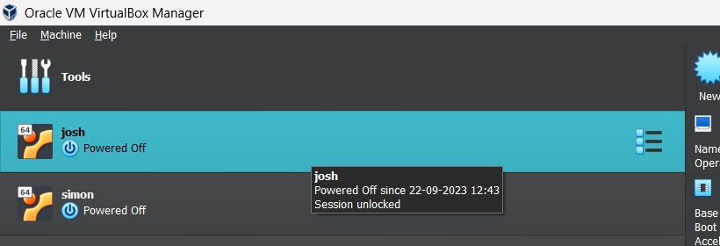

Select "Import Appliance."

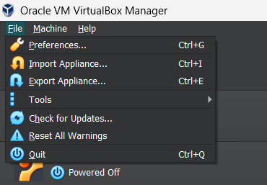

In the "Import Virtual Appliance" dialog, click the "Open Appliance" button and navigate to the location where you downloaded the ownCloud appliance.

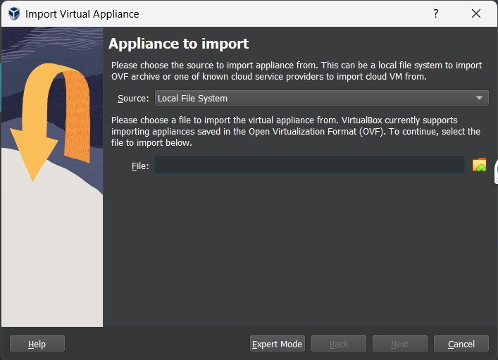

Select the ownCloud OVA or OVF file and click "Open."

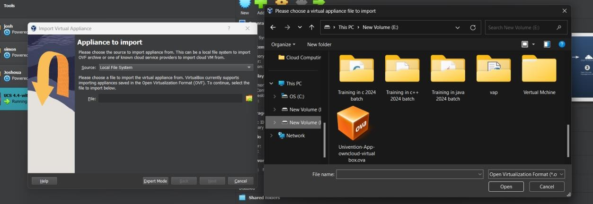

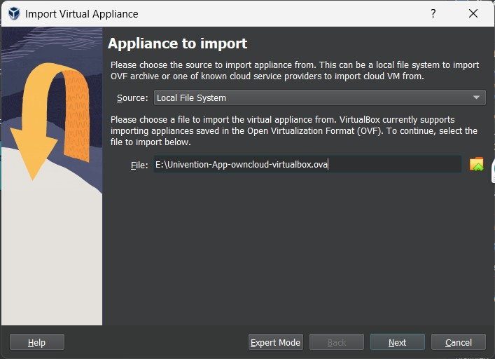

Review the appliance settings and adjust them if necessary.

Click "Import" to begin the import process. This may take some time, depending on your system's performance and the size of the appliance.

# Start the Virtual Machine:

Select the ownCloud virtual machine in VirtualBox. Click the "Start" button to boot the virtual machine.

Set up ownCloud: After the virtual machine has booted, you'll need to follow the on-screen

instructions to set up your ownCloud instance. This typically involves configuring the database, admin user, and other settings.

**Access ownCloud:** Once the setup is complete, open a web browser on your host machine and enter the IP address or hostname of the ownCloud virtual machine to access the ownCloud web interface.

Step a:

Set up the Location and Time zone.

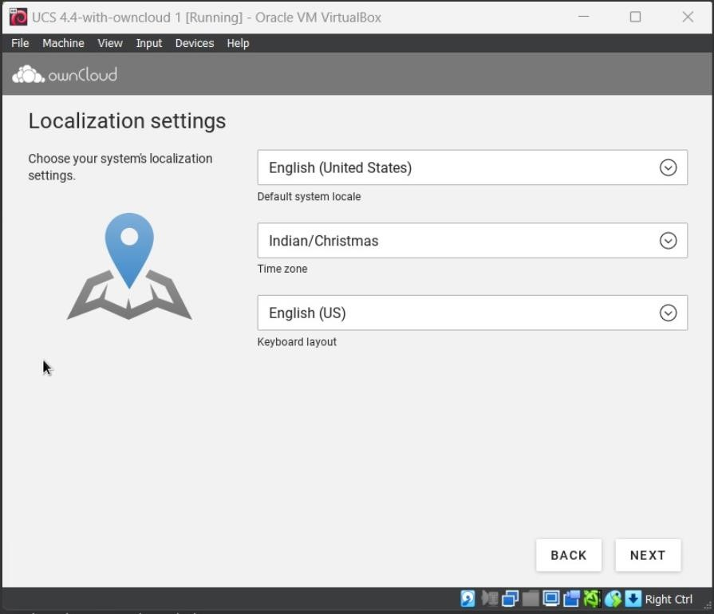

Step b:

Domain Setup.

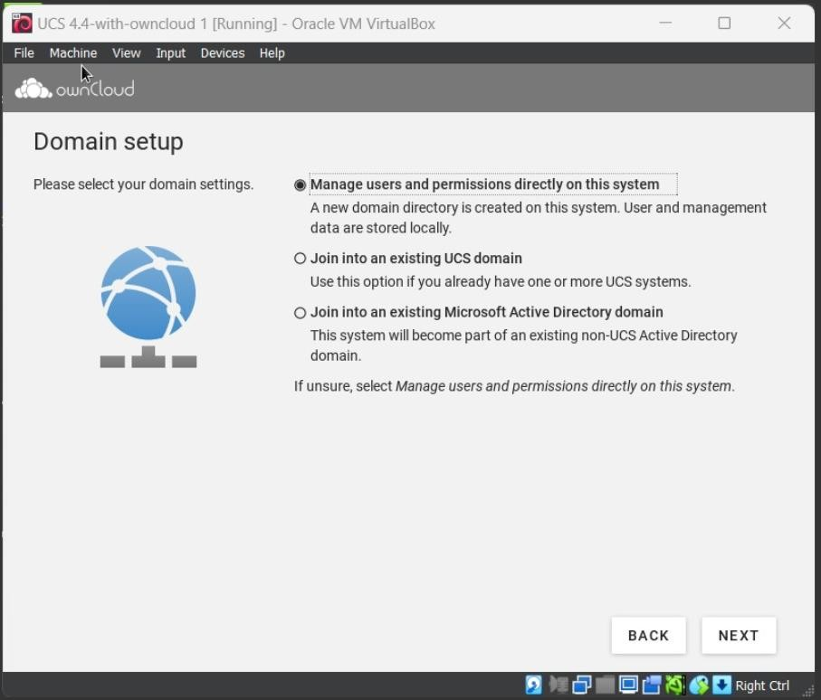

Enter your IpV4 address:

You can do it by using the command **ipconfig** on your windows terminal.

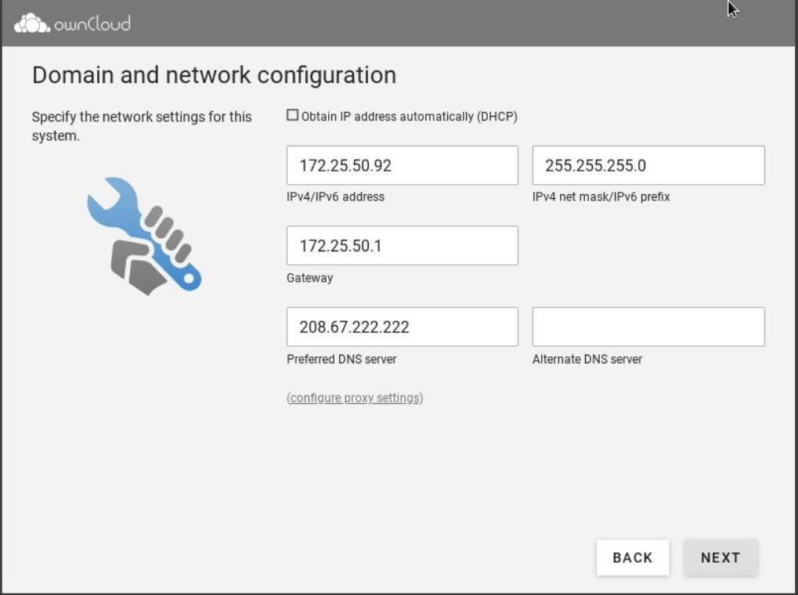

Step c:

Enter the Account details

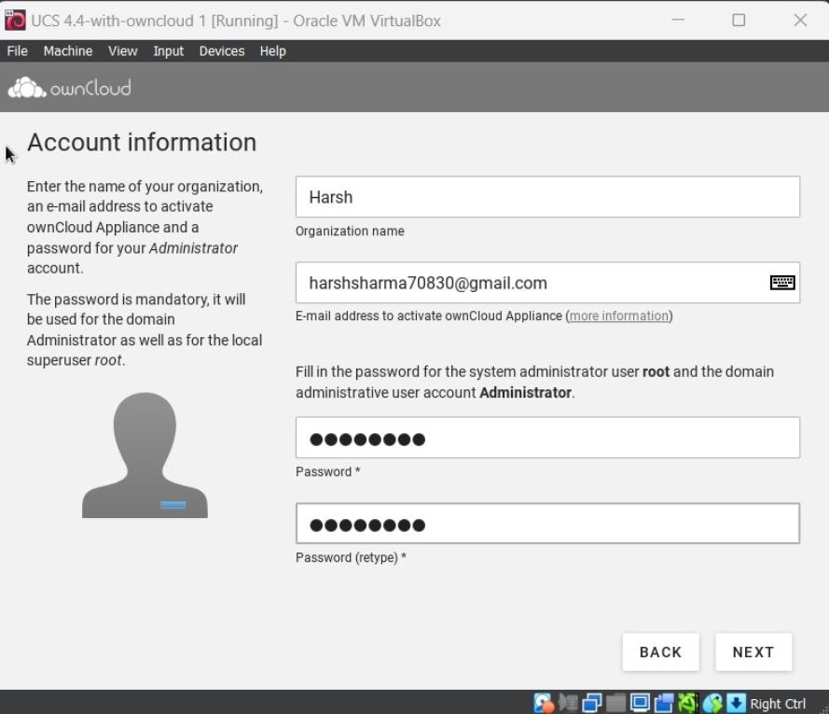

Check the host settings:

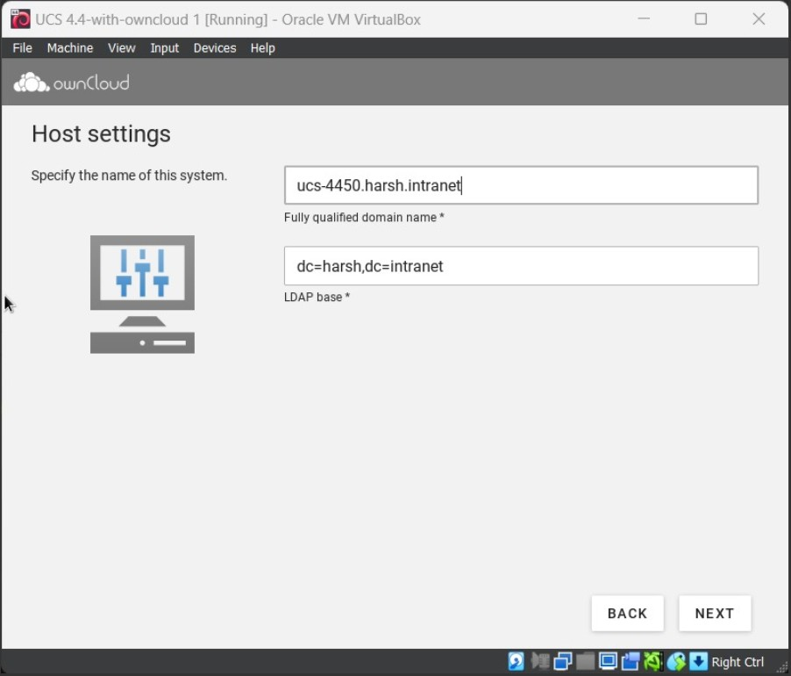

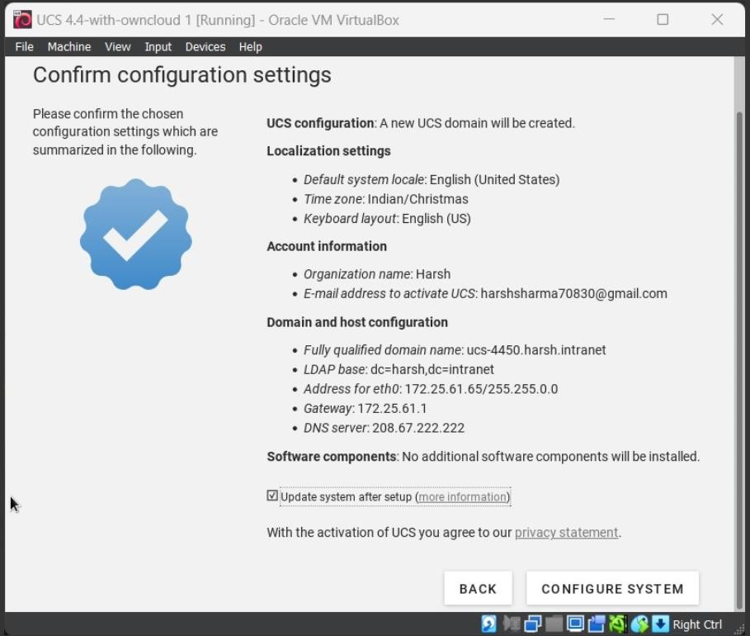

Configure System:

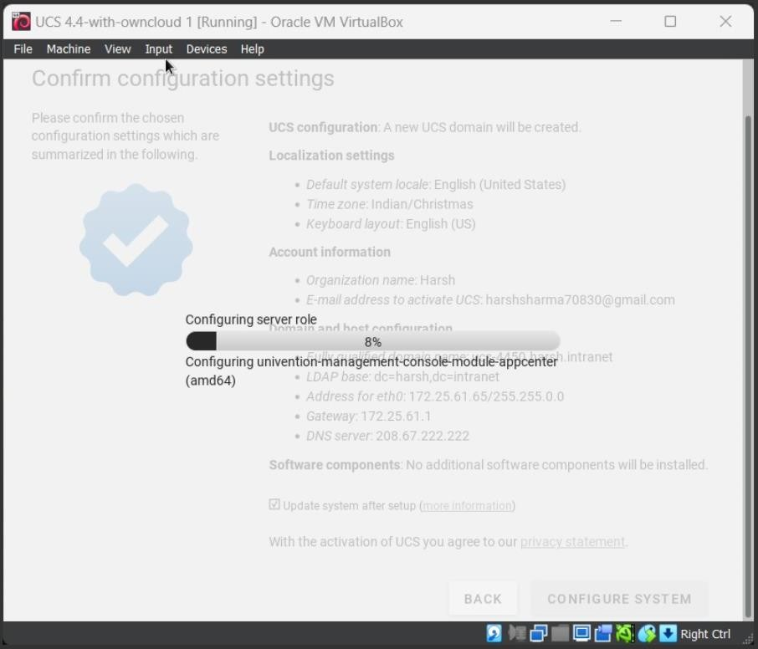

**Login and Use ownCloud:** Log in using the admin credentials you set during the setup process. You can now use ownCloud to store and manage your files, calendars, contacts, and more.

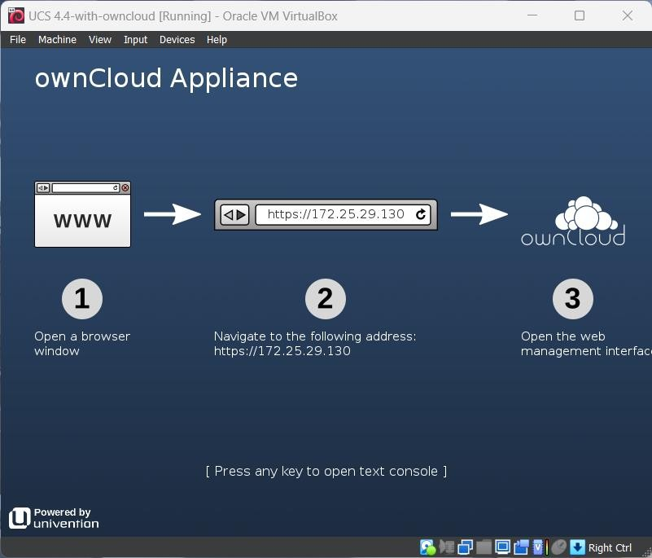

**Note:** After you have navigated to the address of the above picture it will ask your email where it will send the activation link and then you have to upload the license that is sent to your mail then you can access to the portal

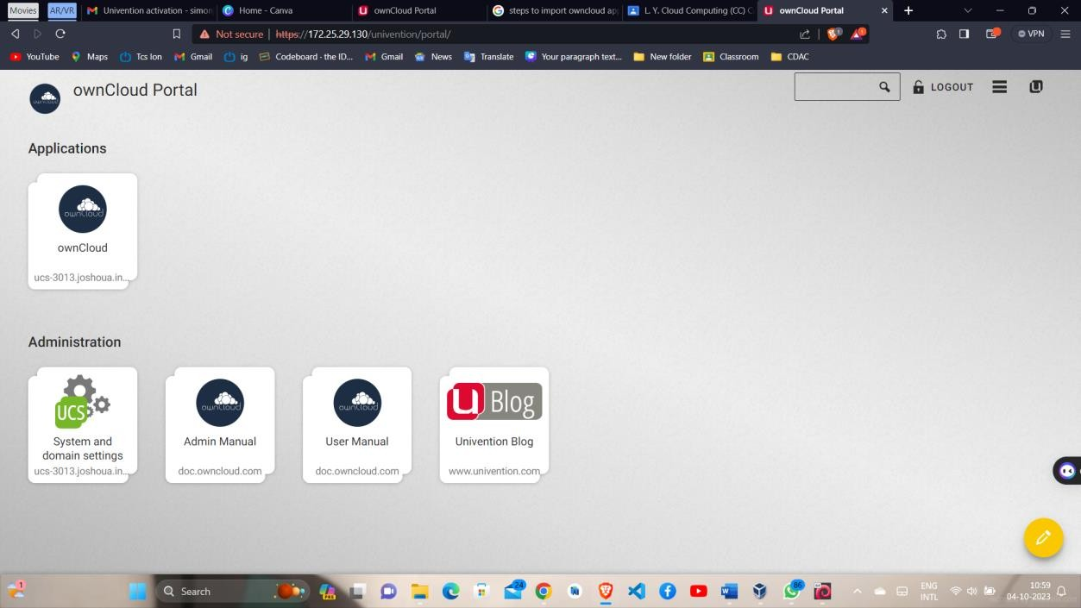

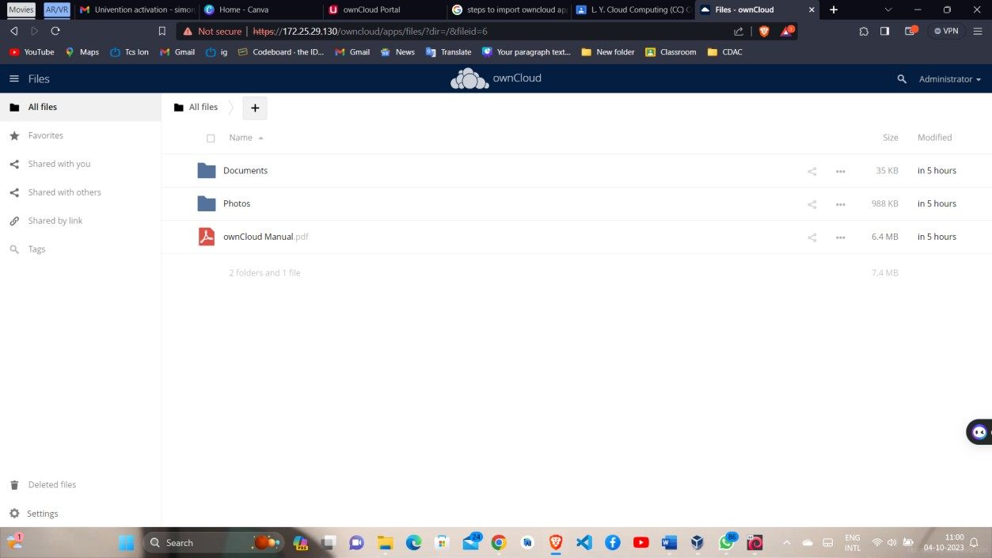

Add file:

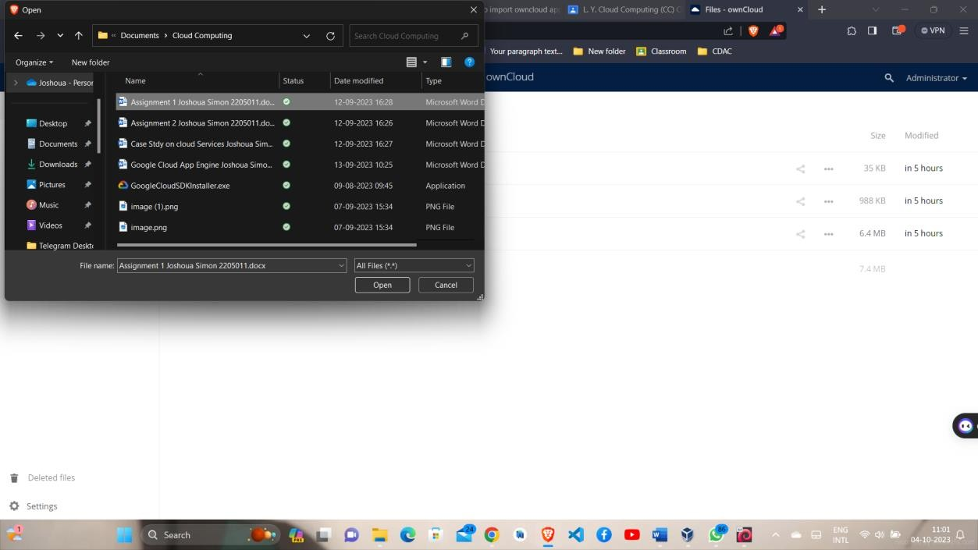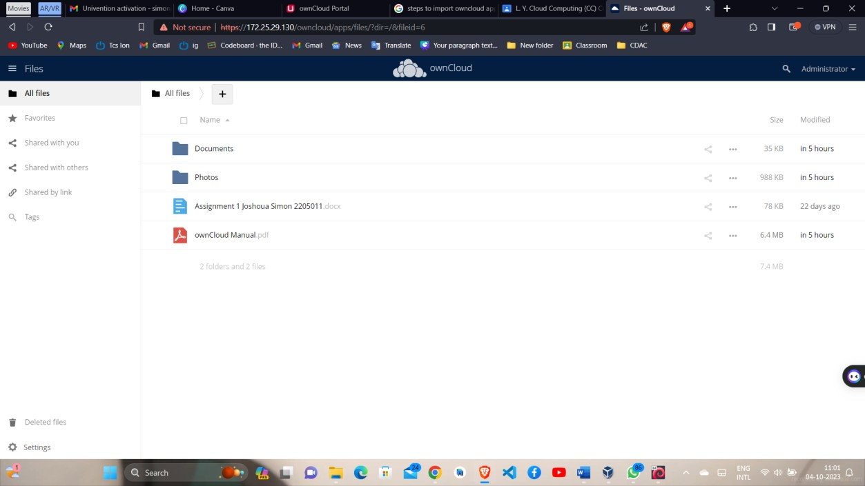

The file is successfully added.

# Conclusion:

That's it! You've successfully imported the ownCloud appliance into VirtualBox and can start using it for your file and data management needs.